Through this research, we aim to understand the flow of the VI application and how the User Interface (UI) is being properly structured and designed.

In the Google Play Store/Apple App Store, there are only limited number of applications designed for the VI. Some of the applications can help to read out physical text from books and newspapers, determine the color of an physical object, or help to identify an object through recognition/online volunteer.

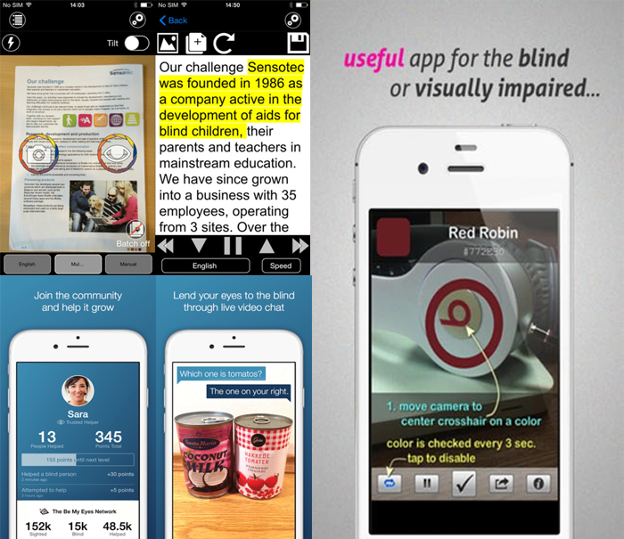

These applications are usually accompanied with Google's TalkBack or Apple's VoiceOver, as every text is read out based on what they have tapped on. In this research, we are going to look on the two popular apps for VI: Airpoly Vision and Be My Eyes.

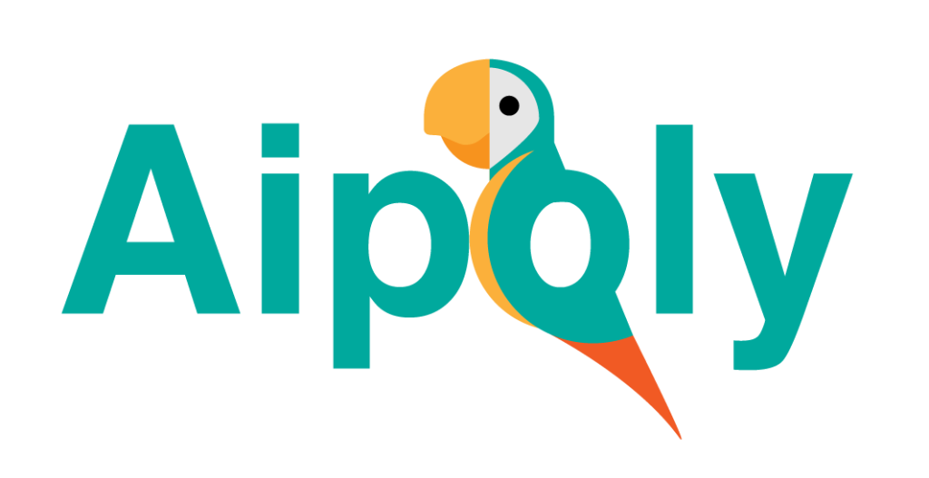

Airpoly Vision is an application where they can recognize and voice out an object or something more precise like a plant, animal, food or a colour by using a camera.

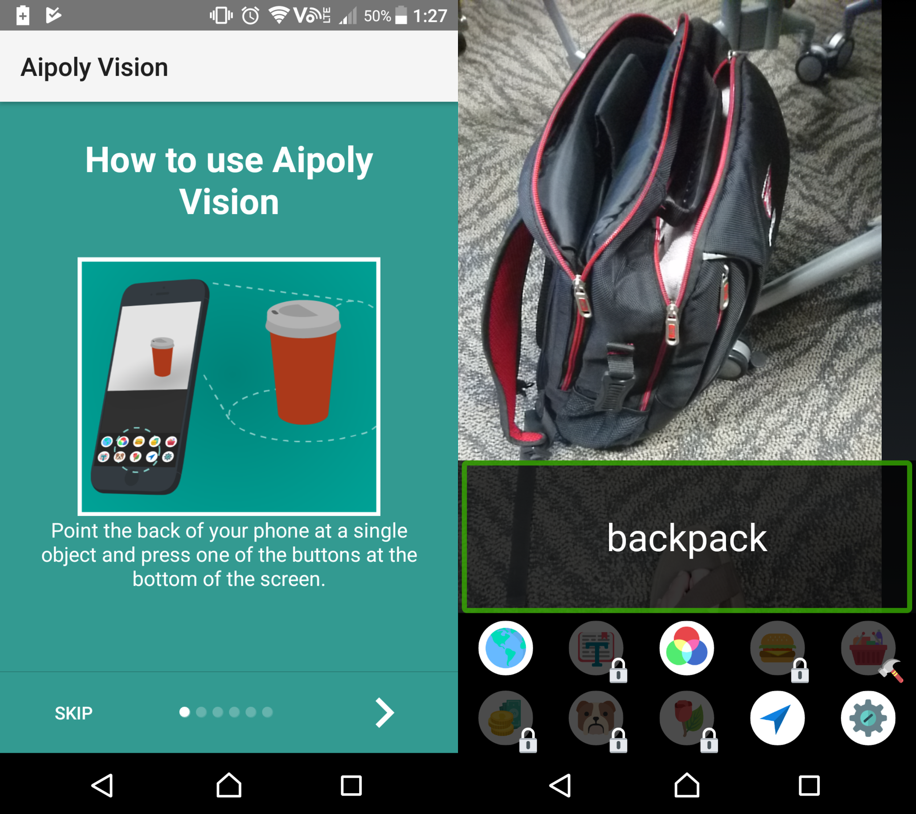

When you first start the application, instructions are shown on how to use it. If TalkBack/VoiceOver is enabled, the instructions can be read by tapping on the words, including the 'next' symbol. After the instructions have been completed, it will not display for every time you startup the application.

The application requires you to allow your permission to use the rear camera, after which you are free to use your camera and identify an object. When they tap the object on the camera screen, it will read out the name of the object e.g. Backpack, laptop. The icons below show the type of object the user wants to know.

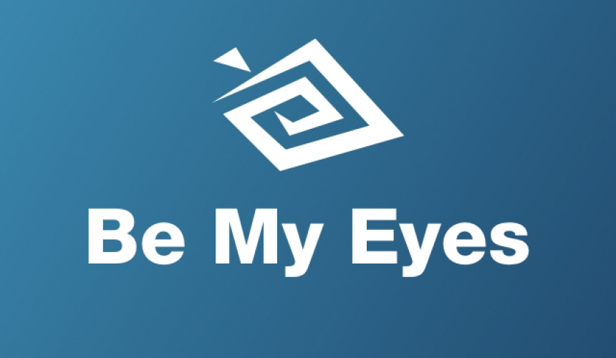

Be My Eyes is an application that connects VI to volunteers online through live video calls. From there, VI users can ask a volunteer to identify what object is it, how many objects are there, etc.

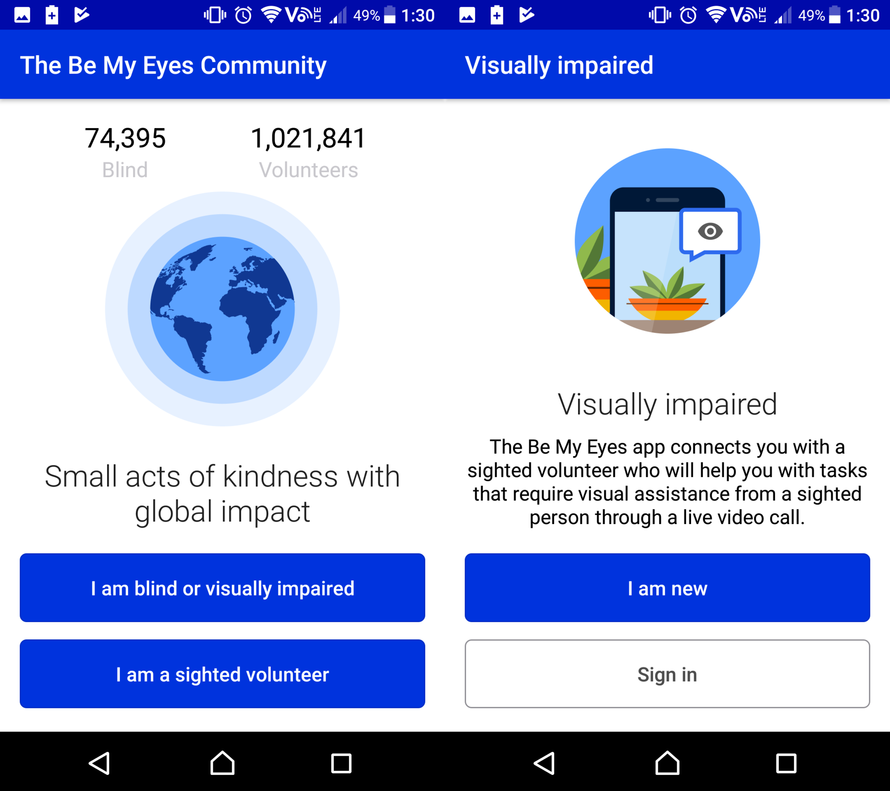

When you first start the application, it will prompt you to agree the Privacy Policy and Terms of Service. Subsequently, you are required to choose whether you are a VI or volunteer, and also sign up an account. In this case, I will choose as a VI user.

The process is much longer than Airpoly Vision's first time setup.

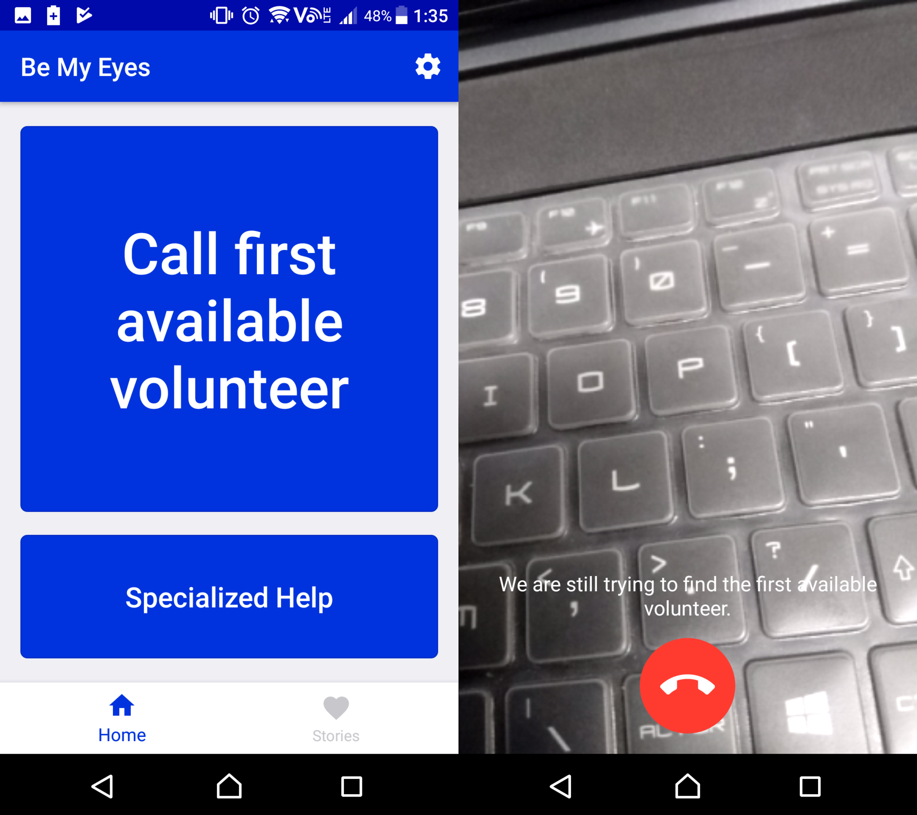

When you are done verifying your email, you are able to call a volunteer. Calling a volunteer will turn on the rear camera and the application will look for an active volunteer.

Through the research on the two applications, we can deduce that for the first time setup, it is usually accompanied with someone who is not VI, and they will help them to register an account and provide instructions on how to use it. Although it is possible for a VI to do it alone, it will take huge amounts of effort and time. For instance, the Be My Eyes application requires you to comply the terms, sign up an account and verify your email, which is a long process.

Secondly, the design of the application is clean and simple as there are not many components on every main page. The details on every page are less and short, which is easy for the VI to understand when they tap on any text.